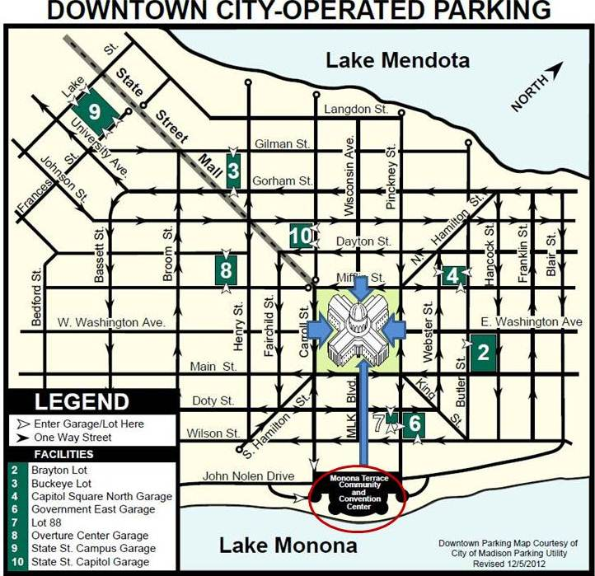

**Accessibility Entrances to the Capitol** are at the end of each wing and beneath the porticos between wings.

**Wheelchair accessible entrances are between the wings, at:**

Martin Luther King, Jr. Blvd.

East Washington Avenue

Wisconsin Avenue

West Washington Avenue

**Restrooms:** 2 women's, 3 men's & 1 unisex on ground floor all with power assisted door openers

**Elevator Signage:** 1 on each side of the grand stairs in South & North wings; 1 on south side of East wing; 1 on north side of West wing.

LOOK FOR THE VOLUNTEERS IN THE **ORANGE** VESTS TO HELP YOU.