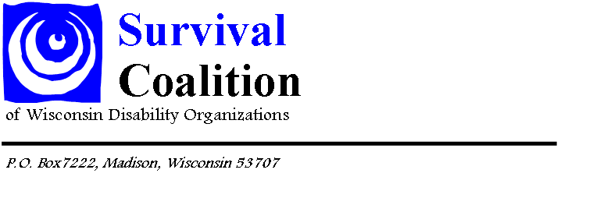
Building Your Personal Message-Disability Advocacy Day
What is the issue?
Circle one of these top issues identified by Survival Coalition:
Long-Term Care Employment
Transportation Education
Mental Health Health Care
Supporting Families Workforce
How does this impact you?
How does this issue relate to your daily life? How could it improve your life? How could it make your life harder?
What is your ask?
What result would you like? How will you know when your problem is solved?

What information could help convince others?
What facts, figures or research could help make your case. Use the Survival Handout to help.

